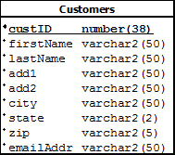

Database

Server Side

Client Side

Pass the table to search results to customerread.jsp

Table is displayed with search result.

customerread.jsp

Table

|  |  |  |  |  |  |  |  |  |
| --- | --- | --- | --- | --- | --- | --- | --- | --- |
| CustID | First Name | Last Name | Add1 | Add2 | City | State | Zip | EamilAddr |
|  |  |  |  |  |  |  |  |  |

searchVal passed as parameter

Search

Search input field (in the index menu bar)

CustomerSearchServlet

ojdbc6.jar

Driver

CustomerSearchQuery

db Conn.properties

driver name=

server name=

user name=

user password=